# **NOTE**: You will have to perform sections B & C at the same time because you will need information from the handset to enter into the IP-DECT and vice-versa. Basically, have the WEBUI open on the IP-DECT master when you are subscribing the phone, you’ll see what I mean as you get into it. Also, this order of the procedure only applies to replacing an existing/defective ASCOM handset where the user already exists on the IP-DECT Gateway, if you are instead adding new handsets to the system, it will also be necessary to add new users to the IP-DECT master (Perform Section “C” below FIRST for each new phone), as well as adding more extensions to the PBX.

# A) Factory Reset Handset

A factory reset can be performed from the handset Admin menu. This is a good first step to help ensure a trouble-free registration.

1. To activate the Admin Menu, enter the Call time screen and press > * < < * <.
2. Select "Factory Reset".
3. A *Reset portable?* dialogue appears, press "Yes". The handset is restarted.

# B) Subscribe From Handset

To subscribe a DECT system manually, the “Park:” (Portable Access Right Key) and “AC:” (Authentication code) related to the system are needed. These are obtained from the WEBUI on the IP-DECT master.

NOTE: The PARK code may not be needed if there is no alien DECT system within the coverage area.

1. Enter the menu by pressing "Menu".
2. Select “Connections” icon in the menu.
3. Select "System".
4. Select "Subscribe".
5. The handset’s IPDI is displayed, enter this number into the appropriate user field on the IPBS as described in section C below. The IPDI is a unique code that has been assigned to the handset.
6. Enter System name (optional). If no system name is entered, the default name is used. That is System A, System B etc. depending on which system name that is free.

Note: The System name might not be displayed depending on the handset’s Display Management Layout setting. See the handset’s Configuration Manual.

1. Press "Next".
2. Enter PARK code (max. 31 digits). The PARK code may not be needed if there is no alien DECT system within the coverage area.
3. Enter AC code. The AC code length must be between 4 - 8 digits.
4. Press "Next".
5. An information text "Protection on?" is displayed. Select "Yes" if the new system is to be protected. It is not possible to delete a protected subscription accidentally from the handset.
6. Press "OK". A searching mode starts.

# C) Registration Preparation From IP-DECT Master

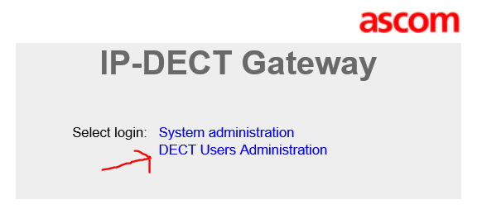

Open the WEBUI of the IP-DECT Gateway using Internet Explorer browser and enter the IP of the Gateway.

The username & password is: admin/changeme

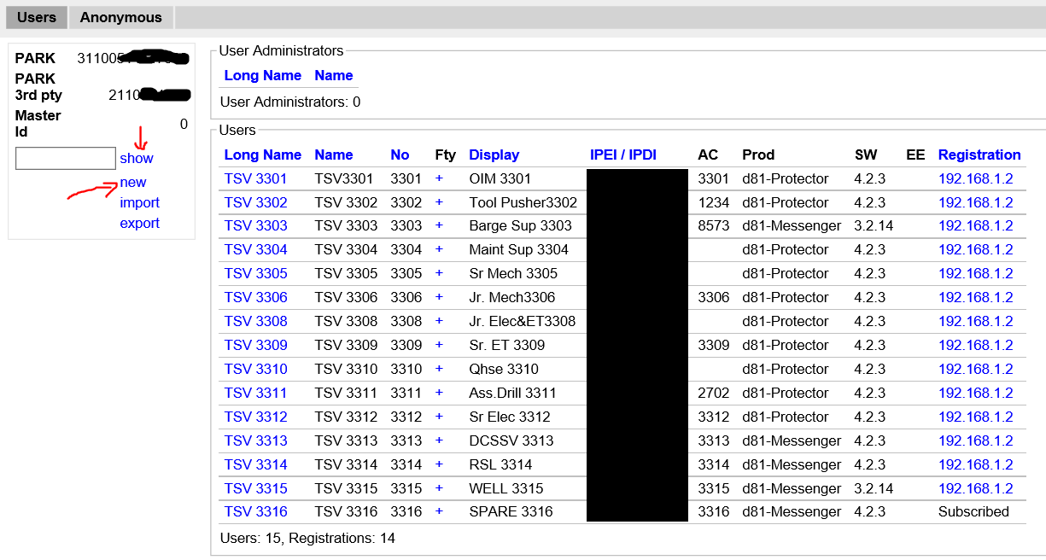

1. Select DECT Users Administration.
2. Select “Show”.
3. Click "New".
4. Enter the following information in the corresponding text fields:

|  |  |  |  |
| --- | --- | --- | --- |
| **Field name** | | **Description** | **Max.**  **characters** |
| • | Long Name | Mandatory, the name of the user, need to be unique throughout the system. | 30 |
| • | Display Name | Optional and only available when using the Ascom VoIP Gateway, the calling or called party name will be shown in the handset display (depending on whose handset). | 30 |
| • | Name | Optional, the user name. | 30 |
| • | Number | Mandatory, the phone number extension, need to be unique throughout the system. (corresponds to the Auth Name on PBX) | 30 |
| • | Password | Optional, is used for registration towards the gatekeeper (PBX). | 30 |
| • | Idle Display | Optional, will be shown in the handset display when the handset is idle. | 47 |
| • | IPEI / IPDI | Mandatory, the unique identification number of the handset. (Obtained in Section B, step 5) |  |
| • | Auth. Code | Optional, the individual authentication code for this user. Automatically created by default. Can be modified manually. |  |

1. Perform an "over air subscription" using the individual authentication code. For information on how this is done, see Section “B” above.
2. Click "OK".